Programming Assignment 3: Building an OWL Ontology

**Prompt 1:** Do any of your classes come out as inconsistent? (They will be show in red in the Class hierarchy tab; you may need to expand to see the red) Explain why and describe a way to resolve the inconsistency?

**Yes**, the 2 classes showed inconsistency when we added disjoints. When we added MeatyVegetableTopping for both MeatTopping and VegetableTopping. We know that some things cannot happen at the same time. A topping cannot be assigned for 2 different topping categories.

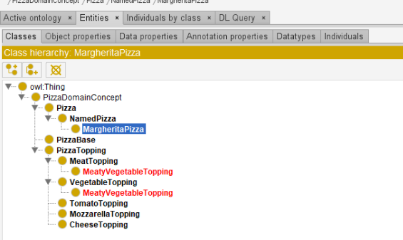

Resolution: We can remove the inconsistency by eliminating the disjoints between the MeatTopping and VegetableTopping. By doing this, there will be no inconsistency as OWL classes ‘overlap’ until they have been stated to be disjoint from each other. So, if certain classes have been incorrectly made disjoint, there will be such errors.

**Prompt 2:**Screen shot of DL queries file upload.

**Add two more pizza and explanation:**

1. FarmhousePizza: This pizza is a veg one and will have multiple toppings like Paneer, Mushroom and Pineapple, and comes only in Thin crust. This pizza will also have different size from Large, medium, and small.
2. VeggieDelightPizza: This pizza is also a veg pizza. This comes in different crusts like thin and thick. Also, the toppings include Onion, Tomato, Corn. Even this pizza comes in all 3 different sizes.

**Add two more PizzaBase and explanation.**

1. CheeseBase: The base of the Pizza will be made of cheese and there are multiple options for the bases. The base can be chosen for any type of Pizzas.
2. GarlicOnionBase: The base of this Pizza will be made of Garlic and Onion and even this base can be chosen for all types of Pizzas.

**Add two more PizzaTopping and explanation.**

1. MushroomTopping: The toppings can be combined with multiple toppings and this topping can also be the only topping on the pizza and can be added only for the large and medium pizzas.
2. JalapenosTopping: This is a vegetarian topping and can be combined with other toppings even for meat pizzas. Can be selected for all types of Pizzas.

**Add at least four more properties and explanation.**

1. PizzaCrust: This will be the crust of the Pizza and comes in 2 different sizes i.e., Thin and Thick.
2. PizzaSize: This will be sizes of the Pizzas and comes in 3 different sizes i.e., Small, Medium, and Large.
3. PizzaSauce: This is the sauces to be added on the Pizza and different sauces generally include Ranch, Tomato Sauce, Garlic Sauce, etc.
4. Nationality: This tells the origin of country of different Pizzas like America, Italy, etc.
5. PizzaShape: The shape of the pizzas is also different in many places. We have Round-shaped, Square and rectangle shaped pizzas.

**The first query of your own choice.**

hasSauce only Tomato

**Explanation of the first query.**

Used this query to know which Pizzas have only TomatoSause.

**Screen shot for the first query.**

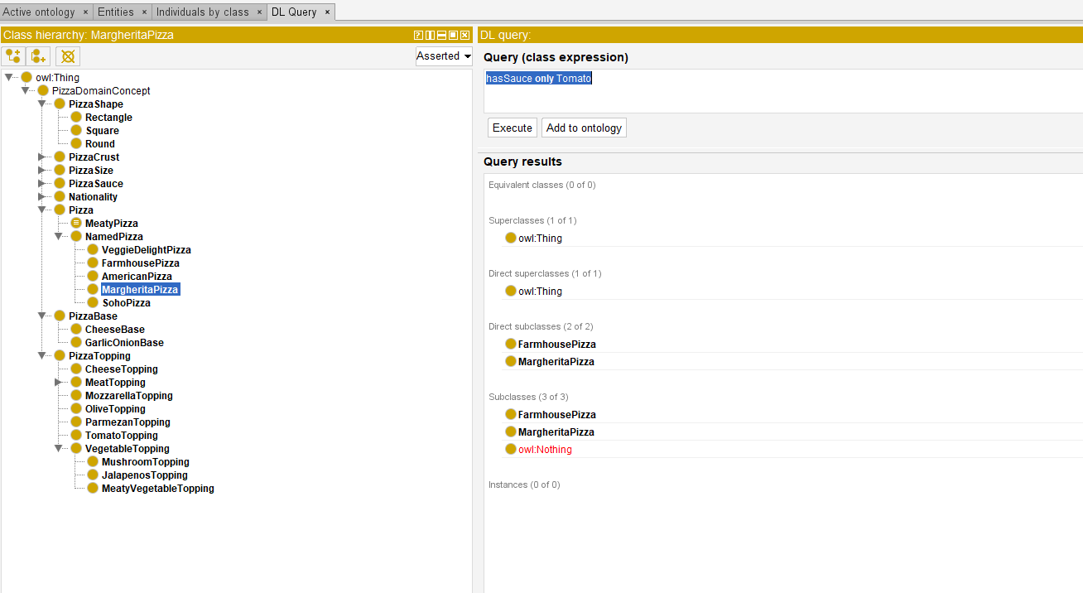

**The second query of your own choice.**

hasNationality only India

**Explanation of the second first query.**

I have used this query to know the different pizzas based out in India.

**Screen shot for the second query.**

